DOCKER

#Installing Docker on Ubuntu - go to official website (Docker docs)

sudo snap install docker

#mkdir fapp2

#touch app.py

**app.py**

from flask import Flask

app=Flask(__name__)

@app.route('/')

def run():

return "vicky punda"

app.run('0.0.0.0',port=5000)

touch Dockerfile

**Dockerfile**

FROM python:3.10

WORKDIR /app

COPY . /app

#RUN pip install -r requirements.txt

RUN pip install flask

EXPOSE 5000

CMD ["python3","app.py"]

touch requirements.txt

**requirements.txt**

Flask==2.0.1

Werkzeug==2.0.1

docker build -t fapp2 .

#Docker.sock permission denied

#cd .. do till you are in /

#do ls -a

#cd var

#cd run

#ls - there is docker.sock

#sudo chmod 666 docker.sock

docker run -p 5000:5000 fapp2

SSH

ssh username@hostname_or_ip_address

**If key pair not generated already**

ssh-keygen

ssh-copy-id username@hostname_or_ip_address

ssh username@hostname_or_ip_address

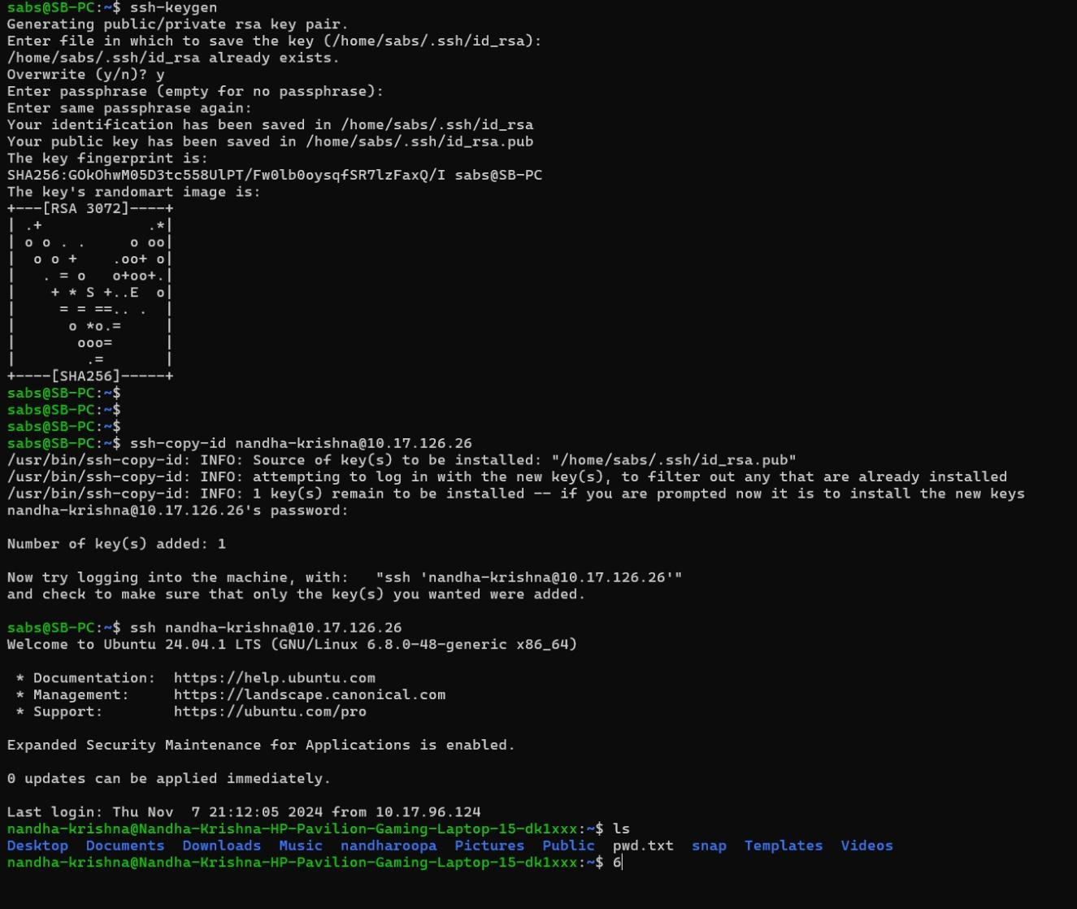

Q) Implement shell script to transfer application data from local server to remote server using SSH (use scp command inside shell script)

Here is a simple shell script to transfer application data from a local server to a remote server using `scp` (secure copy) over SSH. This script will copy a specified directory or file from your local machine to a remote server, ensuring data is transferred securely.

```bash

#!/bin/bash

# Define variables

LOCAL_PATH="/path/to/local/application_data" # Replace with the path to your local data

REMOTE_USER="remote_username" # Replace with your remote server username

REMOTE_HOST="remote_server_ip_or_hostname" # Replace with the remote server IP or hostname

REMOTE_PATH="/path/to/remote/destination" # Replace with the path on the remote server where data will be copied

# Transfer data using scp

echo "Starting data transfer from $LOCAL_PATH to $REMOTE_USER@$REMOTE_HOST:$REMOTE_PATH"

scp -r "$LOCAL_PATH" "$REMOTE_USER@$REMOTE_HOST:$REMOTE_PATH"

fi

```

### Explanation of Script:

1. **Variables**: Set the paths and credentials for the local and remote servers.

2. **`scp` Command**: `scp -r` copies files and directories recursively.

3. **Error Checking**: The `if` statement checks if the `scp` command succeeded. `0` indicates success, while other codes indicate errors.

### Usage:

1. Make sure you have SSH access to the remote server (you may need to exchange SSH keys).

2. Save the script, e.g., `transfer_data.sh`.

3. Make the script executable:

```bash

sudo chmod +x transfer_data.sh

```

4. Run the script:

```bash

./transfer_data.sh

```

This script provides a secure way to transfer application data with `scp`.

JENKINS

sudo apt-get install jenkins

sudo apt-get install fontconfig openjdk-17-jre (if Java doesnt exist)

sudo systemctl start jenkins

sudo systemctl status jenkins

Go to <https://localhost:8080> - default Jenkins server

It will ask for the authentication key. Copy the path and use command

sudo cat “paste_the_path_here”

Paste the key from terminal to the Jenkins server

Create an account with username and password

—------------------------------------------------------------------------

Create a repository with a Java file

For eg: <https://github.com/ssnlabs/jenkins.git>

Jenkins

1. Click New Item
2. Give a name and select Freestyle Project
3. Select Github project and paste repository name

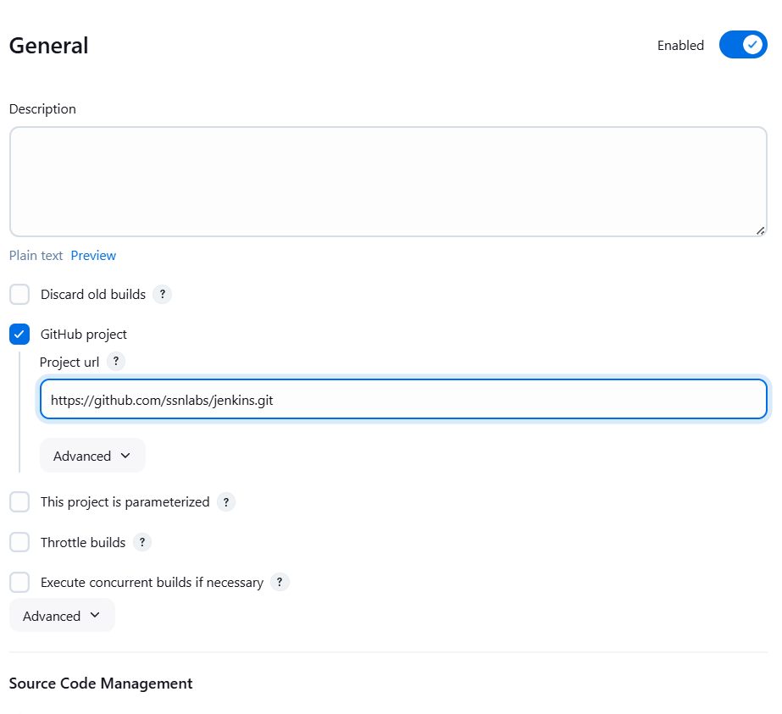

1. Select Git, Under Credentials, Click Add & Jenkins

Change “Branch Specifier” to */main

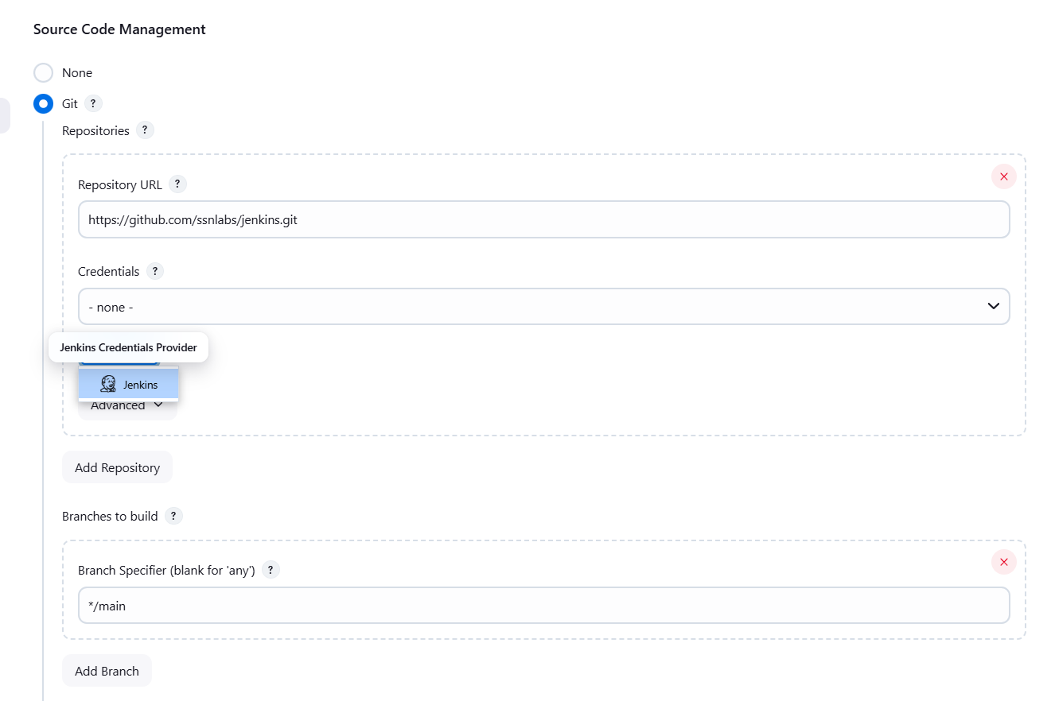

1. Enter your github username and password

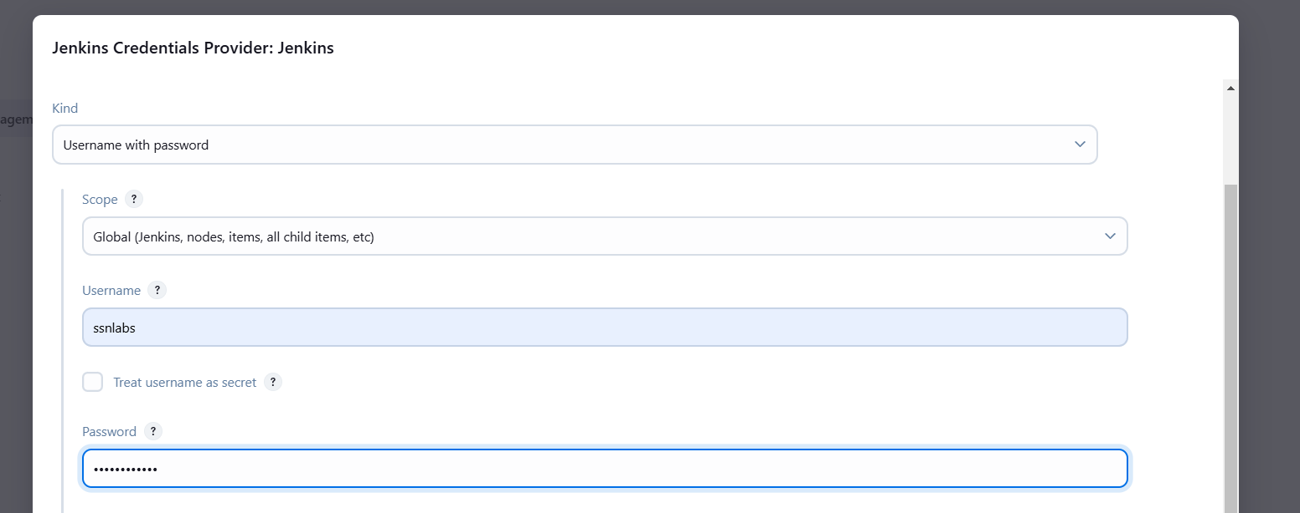

1. Add * * * * * under Build Periodically -> Schedule (Cron Job - triggers a build every minute)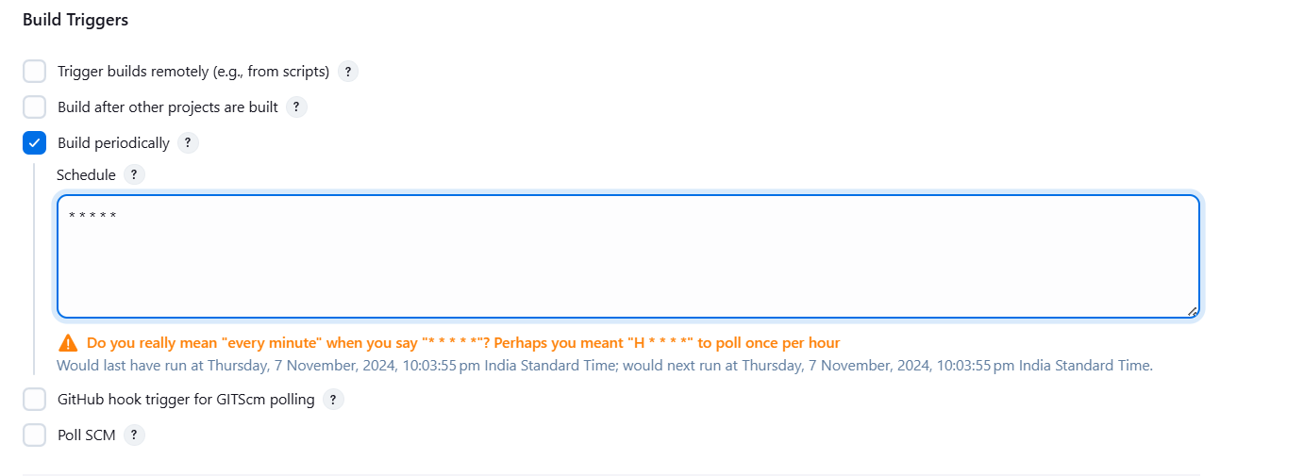
2. Under Build Step -> Select Execute Shell and enter the following

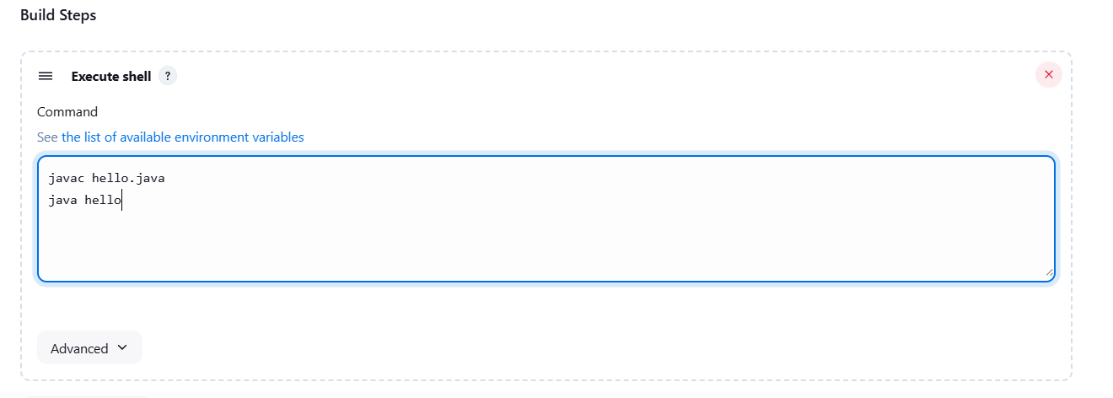

1. Give Save and Build Now in next page
2. Enjoy!

Pipeline script

pipeline {

agent any

stages {

stage('Checkout') {

steps {

// Replace 'your-repository-url' with your repository URL

git url: 'https://github.com/your-repository-url.git'

}

}

stage('Build') {

steps {

// Commands to build the application

// Example for a Node.js application

sh 'npm install'

sh 'npm run build'

}

}

stage('Test') {

steps {

// Commands to run tests

// Example for running Jest tests

sh 'npm test'

}

post {

always {

// Archive test results (JUnit format for example)

junit 'reports/junit/*.xml'

}

}

}

stage('Results') {

steps {

// Display test results in Jenkins

echo 'Displaying test results'

}

}

}

post {

always {

// Clean up workspace if necessary

cleanWs()

}

}

}